Mega

1. To create an account in the service, you need to click on the link:   
<https://mega.nz/>.

2. Click on "Create Account".

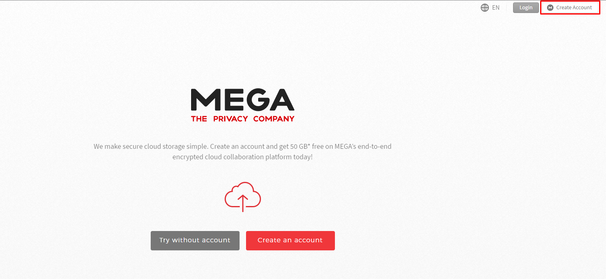

3. In the window that opens, fill in the required information, click on the "Create Account" button.

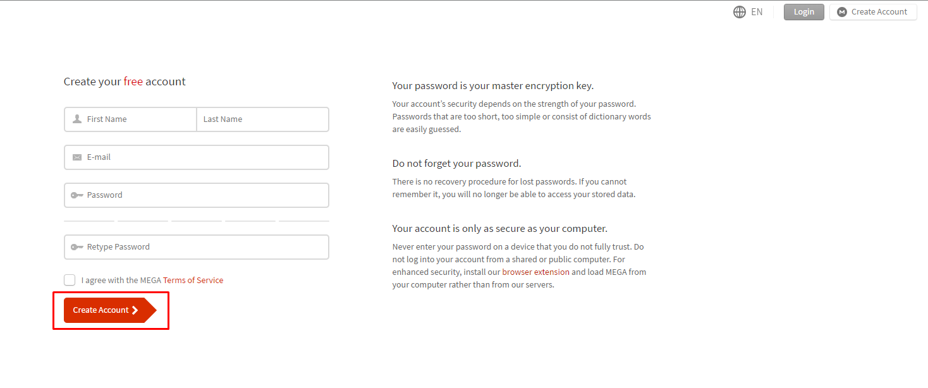

4. Confirm registration via e-mail.

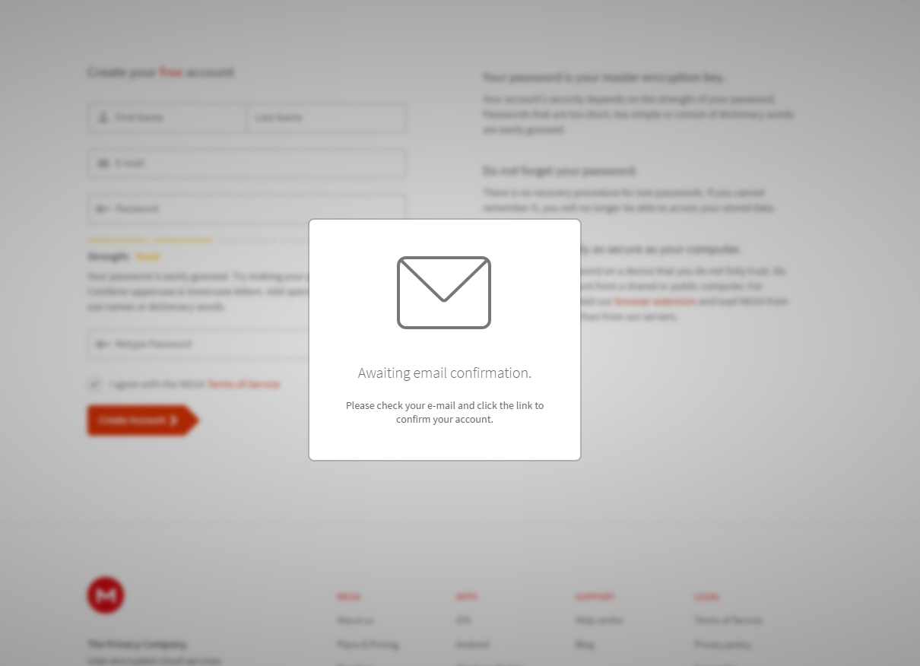

5. In the next window enter your login and password and click on the "Confirm your account" button.

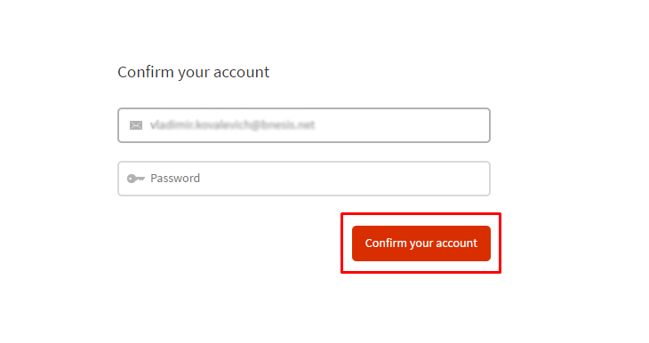

6. Select account type.

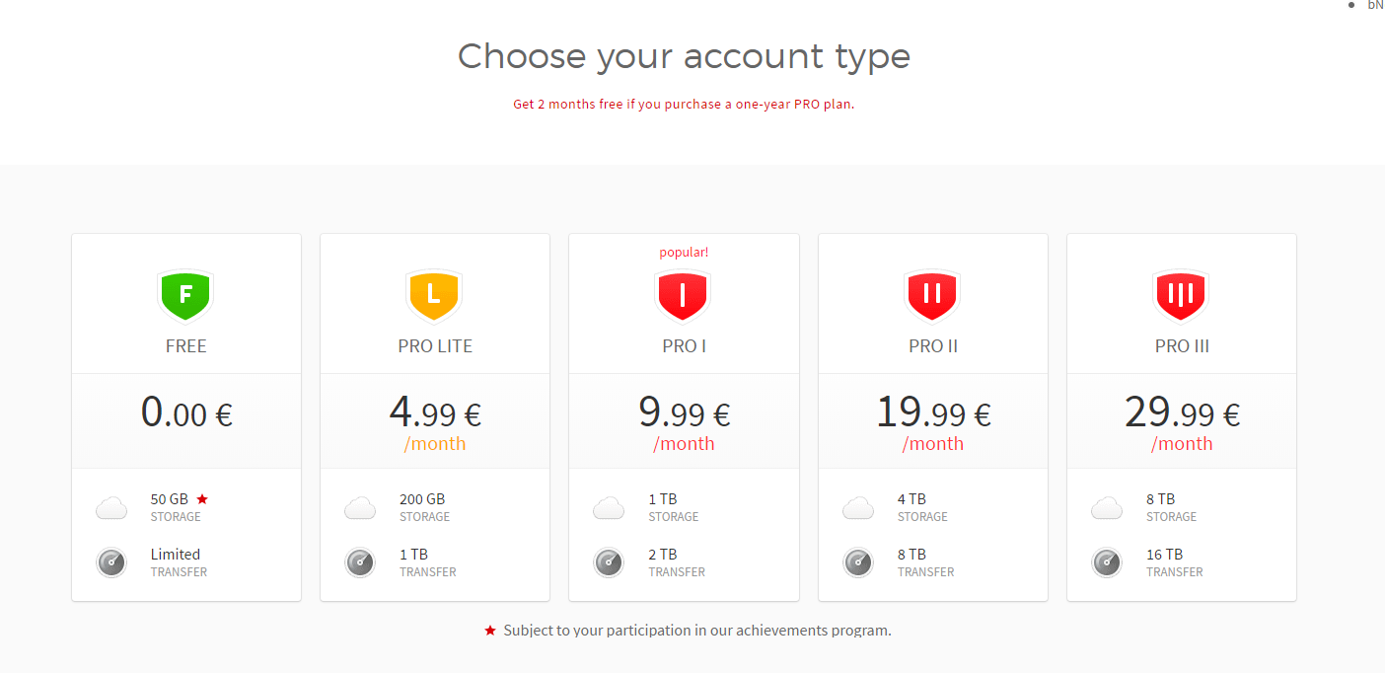

7. Account is created.

8. To register the application, click on the side menu.

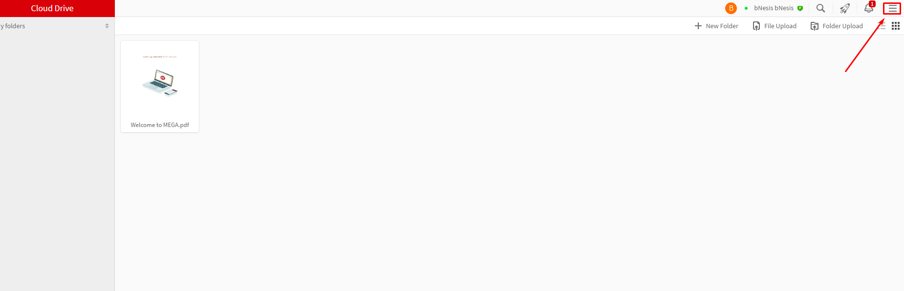

9. Click on the section "Developers".

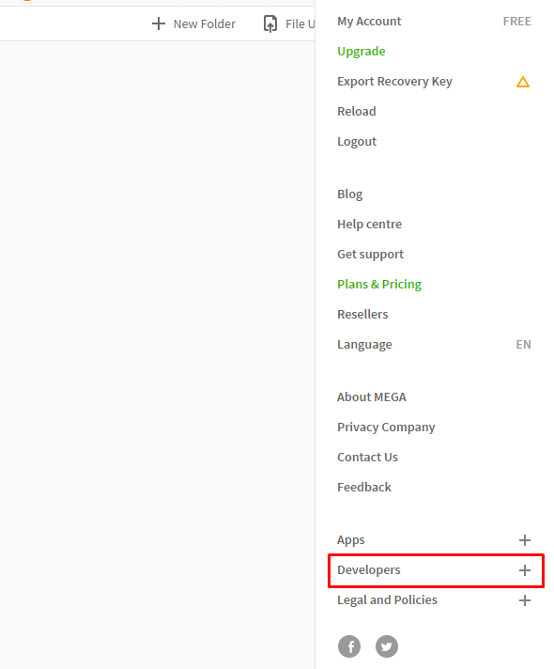

10. Go to the documentation.

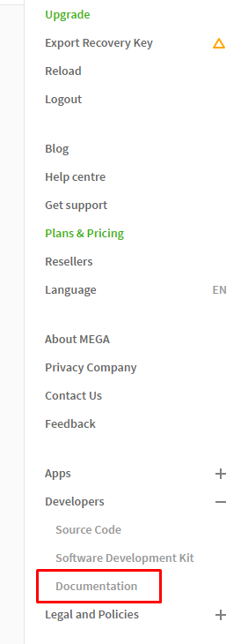

11. On the documentation page that opens, navigate to the Core SDK.

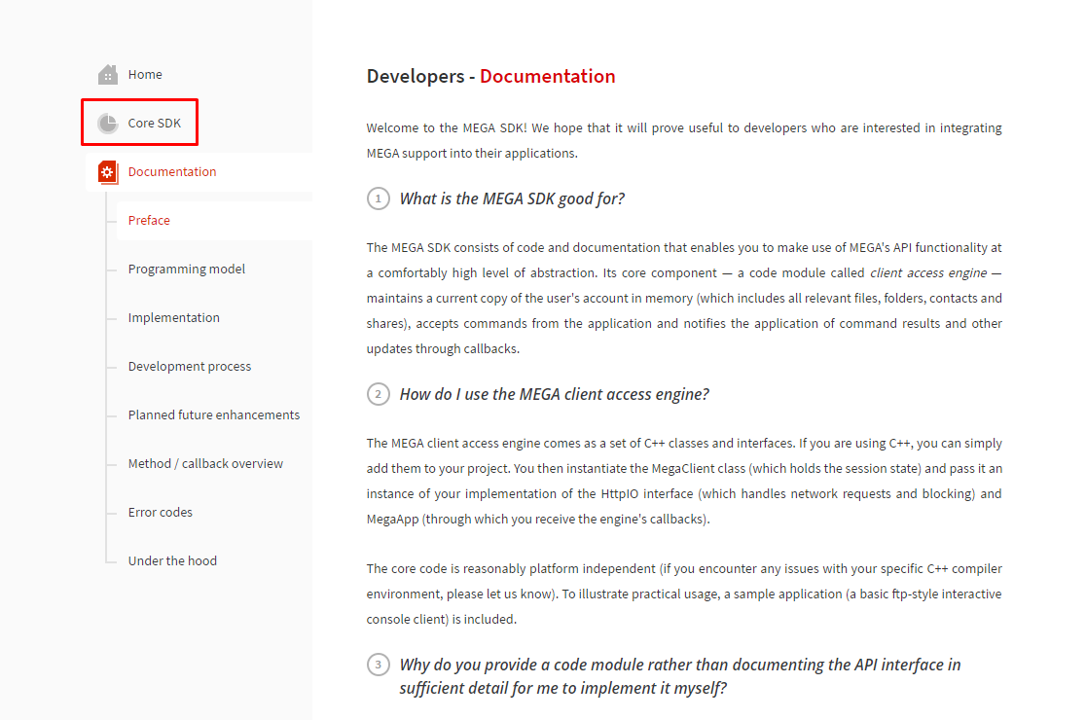

12. Click on "Create an App".  
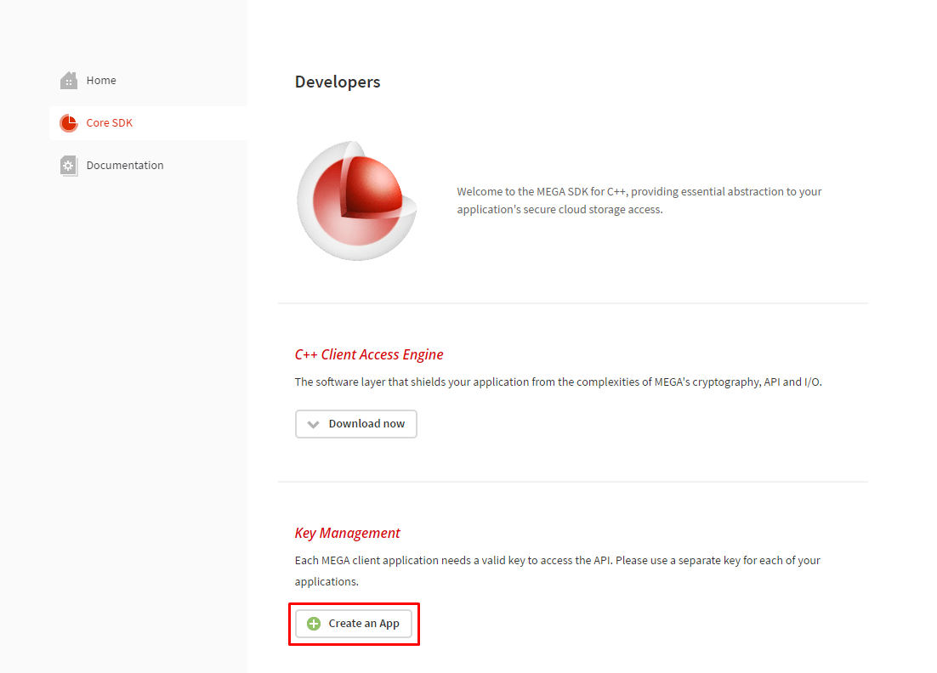

13. Fill out the form and click on "Save".

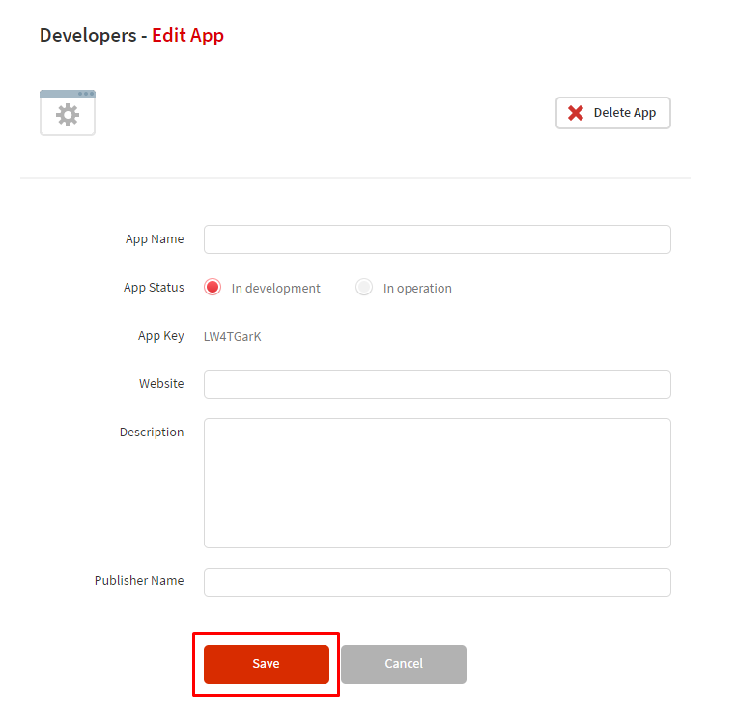

14. Now you can get the application key and use it for authorization in the service in conjunction with the account login and password.

